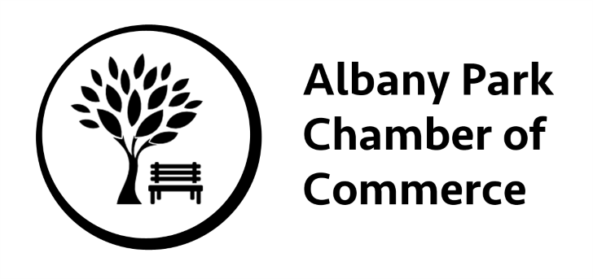
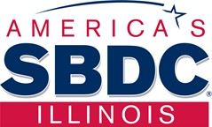
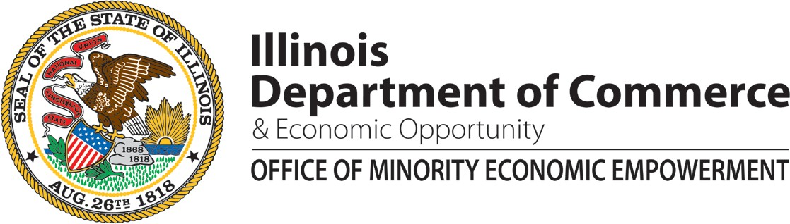

Conducted in English.
Spanish handouts and speakers available as needed.

Keep Your Doors Open: Business Plan to Success

Join us for this informational workshop where subject-matter experts will discuss Business Plans, what they are, their importance, and how to create or re-evaluate them for short and long term success. We will also be discussing the importance of Credit and Access to Capital. Including the Advantage Illinois Loan Participation Program and FAME (Fund for the Advancement of Minority Enterprises).

Open to ALL start up, new, and established businesses!

Topics to be Covered:

Business Plans

What they are, their importance, how to create/reevaluation for success
- Importance of Credit
- Access to Capital
  - State Funding

RSVP for this FREE ADME Business workshop: space is limited

Register at:
Eventbrite enlace: https://adme081319.eventbrite.com

When: Tuesday, August 13, 2019

Time: 9:00 a.m. – 11:00 a.m.
*Workshop begins at 9:30 am

Where: Taquería San Juanito, 4714 N Kedzie Ave, Chicago, IL 60625

omee@illinois.gov

